Starting & Running a Successful Horse Boarding Business 2-Day Barn Management Workshop with Sheri & David Grunska
September 14-15, 2019 (Sat/Sun) 8am-5pm Vinland Stables, Neenah Wis.
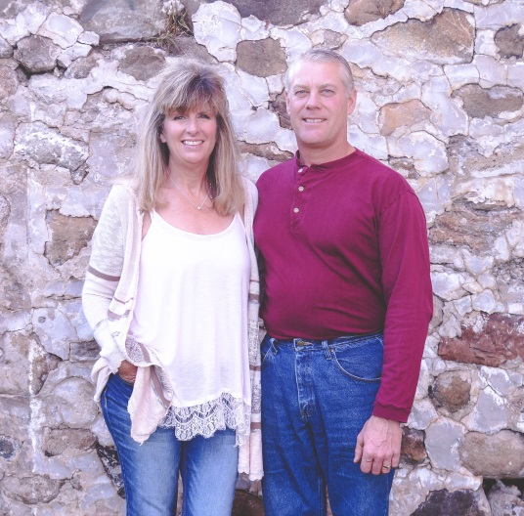
Day 1: Will be spent at Sheri & David’s own Vinland Stables. We will talk about your business and give you a visual to every part of the operation and how it will impact your chores, horses, clients and finances.
Day 2: The second day will be at the Bridgewood hotel & Conference Center in Neenah where we will have an in-depth look into the challenges of owning and managing this type of business and how to overcome those challenges.
During both days we will talk about:
- Designing your barn & stable with all four seasons in mind
- Walking through size and cost verses revenue
- Determining how many horses needed to make it cost effective
- Determining your amenities and how that will affect your board rates and costs yearly
- Chores and how to make them easier and cost effective
- Boarding Contracts, Insurance, Accountants & lawyers
- Barn rules & arena etiquette for safe riding
- Special requests and how that will affect your daily job and costs/ how to set it up for your business
- Hay, grain and supplement considerations including storage and daily feeding
- Issues that are generated in a boarding business
- Trainers at your barn and the financials and liability involved
- Herd management (private or herd turn-out) Paddocks & pastures and determining size and layout
- Barn owner/manager differences-Conflict management with clients and employees
- Billing, invoices, taxes and board rates AND SO MUCH MORE!
This is a fantastic opportunity and business investment for you. Sheri and David built their facility in 2005 and have learned to streamline and become very efficient in how they run their operation seven days a week to make it cost effective. Start with a strong foundation so that you don’t lose thousands of dollars especially during those early years.
The cost of this workshop is only $300 and included will be Sheri’s newest book, “A Step by Step Guide to Starting and Running A Successful Horse Boarding Business,” many learning materials and lunch both days. You can contact Sheri at 920-205-7518 or email at grunska4@sbcgobal.net to reserve your spot. Paypal/checks accepted. Payment must be received by August 20th to reserve your spot. Limited spots available. To learn more about Sheri, please go to her website at www.probarnmanagment.com Get ready to have fun and learn a lot about the type of boarding stable you want to have. You can find her boarding facility online at www.vinlandstables.net Lodging and conference room will be at the Bridgewood Hotel & Conference Center in Neenah, Wi. 920-720-8000. No refunds for cancellation unless the spot can be filled. Please contact Sheri with any questions.

